2012 MAYOR'S PROUD PARTNERS LUNCHEON
​DONORS & SPONSORS
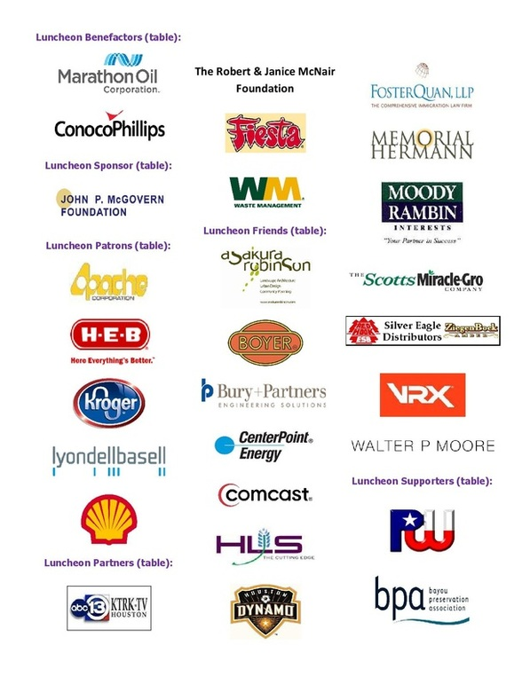
Patrons:  BetterHouston  Greater East End Management District  Artie Lee Hinds  Hermann Park Conservancy  SWA Group Landscape Architects  Westbury Area Improvement Corp  Gary K. Woods  Wulfe & Co.  Friends:  Clark Condon Associates  Coca-Cola Refreshments  Rebecca Jensen Bruhl  Houston Advanced Research Center  Annapurna & Arun Jonnalagadda  Karen B. North  Trent J. Slovack  Frank G. Weary | Partners:  Alief Community Garden  Stanford & Joan Alexander  Robin & Louis Blut  Hilton Americas – Houston  Ruth Hurst  University of Houston –  Gerald D. Hines College of Architecture  Razi Asaduddin  Volunteers:  Annunciation Greek Orthodox Cathedral  City of Stafford  Ramiro Fonseco  Rebuilding Together – Houston

